Connecting Audio Parameters and Modulation
For simple Web Audio API applications, there is often only one type of connection that ever needs to be made, directly connecting one audio node’s output to another audio node’s input. But there are a lot of other types of connections, and a lot more functionality to connecting nodes. This Chapter dives into these connections, with a focus on how an audio node’s output can be connected to a parameter of another node. Examples are provided for Frequency Modulation (FM) Synthesis and Amplitude Modulation (AM) Synthesis

Connections revisited
There are several types of connections available in the Web Audio API. An audio node’s output can be connected to a parameter of another node. Sometimes, nodes may need to be disconnected, or inputs or outputs may need to be specified. Hence, there are a multitude of related methods for connecting and disconnecting nodes. These are all encapsulated by the following methods.
- connect(AudioNode destinationNode, optional output, optional input)
- connect(AudioParam destinationParam, optional output)
- disconnect(optional output)
- disconnect(AudioNode destinationNode, optional output, optional input)
- disconnect (AudioParam destinationParam, optional output)

Lets consider two nodes, nodeA and nodeB, where nodeA has an audio parameter paramA and nodeB has an audio parameter paramB. So the basic
nodeA.connect(nodeB)
is what we have seen already.
There is also an optional output and optional input, both of which are indices. So we could have,
nodeA.connect(nodeB, output, input)
output states which output stream of nodeA the connection is from, and input states which input stream of nodeB the connection is to.
But nodes can also connect to parameters,
nodeA.connect(nodeB.paramB)
And we can specify which output from the node connects to the parameter,
nodeA.connect(nodeB.paramB, output)
Unlike when connecting two nodes however, it wouldn’t make sense to give an argument for input since the audio parameter has a single value.
The general rule is, if an audio node has any nodes connected to its input, then the output of those nodes are summed together to create an input buffers for the audio node. This is then up-mixed or down-mixed to match the number of input channels of this audio node.
When connecting to an audio parameter, the parameter will take the audio streams that connect to it and convert them to mono by down-mixing if need be. These streams are summed together with the intrinsic parameter value. This intrinsic parameter value is the value that the audio parameter would normally have without any audio connections.
There are some common rules for all connections.
The destination for any connection, whether an audio node or audio parameter, must belong to the same audio context as the node that the connection is from. That is, AudioNodes cannot be shared between AudioContexts.
Multiple audio nodes can be connected to the same audio node or audio parameter. Similarly, an audio node can connect to multiple audio nodes and audio parameters.
An audio node can connect to itself, to one of its own parameters, or to other nodes which eventually connect back to the original node or one of its parameters. So we can have,
nodeA.connect(nodeA);
or
nodeA.connect(nodeA.paramA);
There can only be one connection between a given output of one specific node and a given input of another specific node. Multiple connections with the same termini are ignored. So,
nodeA.connect(nodeB);
nodeA.connect(nodeB);
will have the same effect as
nodeA.connect(nodeB);
Some of these scenarios are depicted in Figure 6.1.
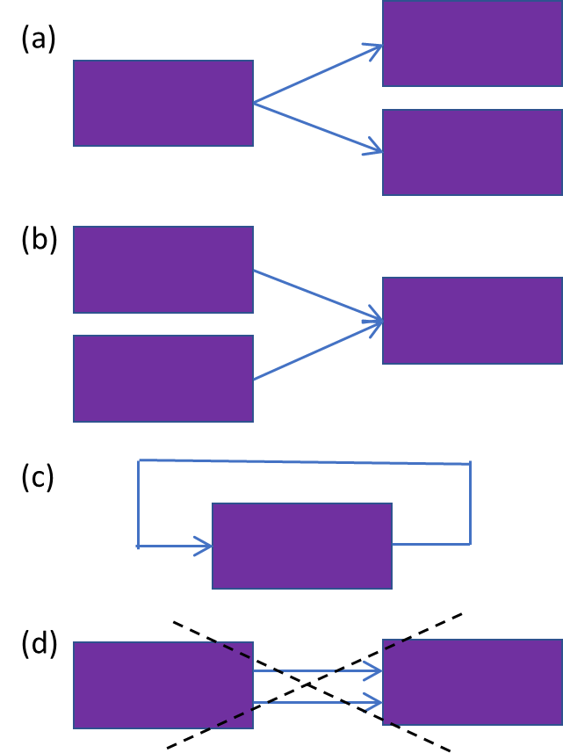
Figure 6.1. An audio node can connect to several different nodes or parameters (a), several nodes can connect to an audio node or parameter (b), an audio node can connect back to itself or one of its own parameters (c), but an audio node cannot have several connections to the same audio node or parameter (d).

Disconnecting nodes
There are more options for disconnecting nodes than for connecting nodes, since one may, for instance, sever all connections from a node without specifying what those connections connect to. One could state
nodeA.disconnect();
to achieve this.
If the node has several outputs, then one might specify which output to disconnect,
nodeA.disconnect(output)
where output is an index describing which output of the AudioNode from which to disconnect. We haven't specified which connection from that output, so it would disconnect all outgoing connections from that output.
One could also be specific about the destination node or parameter. Then we get methods that are analogous to how connections are made,
disconnect(destinationNode, optional output, optional input)
This allows one to disconnects all outputs that go to a specific destination node, or disconnect a specific output going to that destination, or disconnect a specific output going to a specific input of the destination.
Similarly,
disconnect(destinationParam, optional output)
allows one to disconnects all outputs that go to a specific destination audio parameter, or disconnect a specific output going to that destination.
When disconnecting a connection to an audio parameter, the intrinsic value is not affected. So if we have a ConstantSourceNode with an offset of 0.5, and a GainNode with a gain value of 1. Then if the ConstantSourceNode connects to the GainNode's gain parameter, the computed value of that gain parameter becomes 1+0.5=1.5. But when we disconnect that connection, the computed value of that gain parameter returns to its intrinsic value of 1.

Connecting audio parameters
The audio parameter can also be changed by connecting some other node to the parameter, someNode.connect(offset.value), In which case, the audio output from the connected node will sum with the intrinsic parameter value. But that still leaves the question of how the other node will output the preferred value at a given time.
Note that the automation curves described in Chapter 5 only reset the intrinsic value of a parameter. So if, for instance, we had
someConstantSourceNode.connect(someGainNode.gain);
someGainNode.gain.setValueAtTime(0, context.currentTime + 1);
then the intrinsic value still jumps to 0 after one second. But the computed value is the sum of this intrinsic value and all nodes connected to the audio parameter. If default values are used, 1 for the gain of a GainNode and 1 for the offset of a ConstantSourceNode, then the computed gain parameter (in other words, the gain that is actually applied) is 1 + 1 = 2 before one second and 0 + 1 = 1 after 1 second.

Example - FM Synthesis
Modulation involves varying properties of a periodic waveform, known as the carrier signal, with a modulating signal, known as the modulator signal. A specific form of modulation is FM (for Frequency Modulation) synthesis. This involves creating sound by modulating the frequency of a waveform using another waveform. It was first discovered by John Chowning (Chowning, 1973).
Consider a simple sinusoid, $x(t)=A\sin{(}2πft+ϕ)$. If one varies A, that is amplitude modulation. Varying f produces frequency modulation, and varying phase$ϕ$ produces phase modulation. Technically, what we will do here is phase modulation. This is more common than frequency modulation, and the two effects are very similar.
Formally, we define the carrier as
$$x_{c}(t)=\sin{(}2πf_{c}t),$$
where f_{c} is the carrier frequency, or frequency offset, which gives the fundamental frequency.
Now we modulate the frequency with some modulator $x_{m}(t)$. The carrier typically has much higher frequency than the frequencies contained in the modulator signal. In FM radio, the modulator is the broadcast material. In FM synthesis, this modulator is typically a sinusoid. This results in the following output signal after frequency modulation is applied.
$$x_{m}(t)=D\sin{(}2πf_{m}t)$$
$$→y\left(t\right)=\sin{(}2π(f_{c}+x_{m}(t))t)$$
$=\sin{(}2π(f_{c}+D\sin{(}2πf_{m}t))t)$,
where f_{m} is the modulation frequency, and D is the modulation depth. An example of FM synthesis is shown in Figure 6.2.

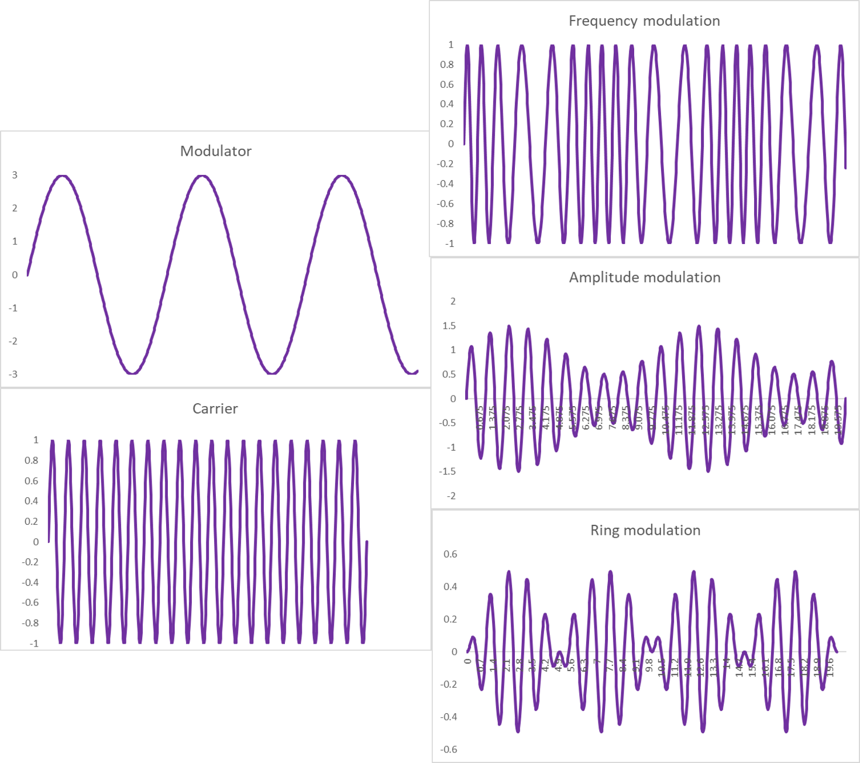.2. Depiction of FM synthesis, AM synthesis and ring modulation.
This is incredibly simple, but choice of f_{c}, f_{m} and D can yield a very rich range of sounds.
Implementation in the Web Audio API is also straightforward. It is shown in Code example 6.1.
We create two oscillators, one each for the carrier and the modulator. The carrier frequency is given by the intrinsic value of the frequency audio parameter of the carrier. The modulator oscillator is connected to a gain node, to provide a modulator with the modulation depth. All relevant parameters; the carrier frequency, modulation frequency and modulation depth, are exposed and can be controlled with sliders.
<input type='button' value='Start/Stop' id='StartStop'>
<p>Carrier Frequency</p>
<input type='range' min=50 max=2000 value=800 step='any' id='CarrierFrequency'>
<span id='CarrierFrequencyLabel'></span>
<p>Modulation Depth</p>
<input type='range' min=0 max=1000 value=200 step='any' id='ModulationDepth'>
<span id='ModulationDepthLabel'></span>
<p>Modulation Frequency</p>
<input type='range' min=10 max=200 value=100 step='any' id='ModulationFrequency'>
<span id='ModulationFrequencyLabel'></span>
<script>
//User Interface callbacks
CarrierFrequency.oninput = function() {
CarrierFrequencyLabel.innerHTML = this.value
Carrier.frequency.value=this.value
}
ModulationDepth.oninput = function() {
ModulationDepthLabel.innerHTML = this.value
Modulator.gain.value=this.value
}
ModulationFrequency.oninput = function() {
ModulationFrequencyLabel.innerHTML = this.value
ModulatorOsc.frequency.value=this.value
}
StartStop.onclick = function() {
if (context.state === 'suspended') context.resume()
else context.suspend()
}
</script>
<script src='FMSynthesis.js'></script>
//Define context and nodes
context = new AudioContext()
var Carrier = new OscillatorNode(context,{frequency:CarrierFrequency.value})
var ModulatorOsc = new OscillatorNode(context,{frequency:ModulationFrequency.value})
var Modulator = new GainNode(context,{gain:ModulationDepth.value})
//start any scheduled sources
Carrier.start()
ModulatorOsc.start()
//Modulator is a gain node, so this multiples ModulatorOsc with the modulation depth
ModulatorOsc.connect(Modulator)
//Carrier frequency is the sum of the intrinsic frequency offset and the modulator
Modulator.connect(Carrier.frequency)
Carrier.connect(context.destination)
Code example 6.1. FMSynthesis.html and FMSynthesis.js, showing how FM synthesis is performed by connecting a Low Frequency Oscillator to the frequency parameter of another oscillator.
The only interesting thing going on here is that the modulator is connected to the carrier's the frequency parameter. The calculated frequency is then the sum of the intrinsic frequency value and the current value of the modulator, i.e, modulating the carrier's frequency.
A vibrato effect is very similar to FM synthesis. For vibrato, the carrier is the signal of interest, and the modulator is a Low Frequency Oscillator (LFO), typically between 0.5 and 10 Hz. However, vibrato is not implemented in the same way as FM synthesis, since one does not typically have a carrier signal represented as simple periodic signals, like a single sinusoid. So instead, the modulation is most often performed by varying the delay on a delay line. An example of this is given in Chapter 10.

Example - AM Synthesis
As with Frequency Modulation (FM), Amplitude Modulation (AM) is used as a broadcasting protocol as well as in audio synthesis. The FM technique uses a modulating frequency to alter the frequency of the carrier signal while AM uses a modulating frequency to alter the carrier’s amplitude (Creasey, 2017; Reid, 2000). FM has a higher fidelity since it is less susceptible to interference, but AM is still used for voice-based broadcasts like news and sports.
The carrier signal is some sinusoid $x_{c}(t)$, as defined before for FM synthesis.
Now modulate the amplitude with some modulator $x_{m}(t)$.
$$x_{m}(t)=D\sin{(}2πf_{m}t)$$
$$→y\left(t\right)=(1+x_{m}(t))\sin{(}2πf_{c}t)$$
$=\sin{(}2πf_{c}t)+D\sin{(}2πf_{m}t)\sin{(}2πf_{c}t)$,
where f _{m} is the modulation frequency, and D is the modulation depth.
This is shown in Code example 6.2. All relevant parameters; the carrier frequency, modulation frequency and modulation depth, are exposed and can be controlled with sliders.
We create two oscillators, one each for the carrier and the modulator. The carrier frequency is given by the intrinsic value of the frequency audio parameter of the carrier. The modulator is constructed by connecting the modulator oscillator to a gain node, with the gain parameter set to the modulation depth. Modulation then consists of using another gain node to multiply the carrier by one plus the modulator, where one is just the default, intrinsic value of the gain parameter for this second gain node.
<input type='button' value='Start/Stop' id='StartStop'>
<p>Carrier Frequency</p>
<input type='range' min=50 max=2000 value=800 step='any' id='CarrierFrequency'>
<span id='CarrierFrequencyLabel'></span>
<p>Modulation Depth</p>
<input type='range' min=0 max=1 value=0.1 step='any' id='ModulationDepth'>
<span id='ModulationDepthLabel'></span>
<p>Modulation Frequency</p>
<input type='range' min=10 max=200 value=100 step='any' id='ModulatorFrequency'>
<span id='ModulatorFrequencyLabel'></span>
<script>
CarrierFrequency.oninput = function() {
CarrierFrequencyLabel.innerHTML = this.value
Carrier.frequency.value=this.value
}
ModulationDepth.oninput = function() {
ModulationDepth.innerHTML = this.value
Modulator.gain.value=this.value
}
ModulatorFrequency.oninput = function() {
ModulatorFrequencyLabel.innerHTML = this.value
ModulatorOsc.frequency.value=this.value
}
StartStop.onclick = function() {
if (context.state === 'suspended') context.resume()
else context.suspend()
}
</script>
<script src='AMSynthesis.js'></script>
context = new AudioContext()
var Carrier = new OscillatorNode(context)
var ModulatorOsc = new OscillatorNode(context,{frequency:100,type:'square'})
var Modulator = context.createGain()
var AM = context.createGain()
Carrier.start()
ModulatorOsc.start()
ModulatorOsc.connect(Modulator)
Modulator.connect(AM.gain)
Carrier.connect(AM)
AM.connect(context.destination)
Code example 6.2. AMSynthesis.html and AMSynthesis.js, for implementing AM synthesis by connecting a Low Frequency Oscillator to the gain parameter of a gain node..

Tremolo and vibrato
At modulating frequencies around 6 Hz, an amplitude modulated signal resembles a tremolo effect. This is done using a Low Frequency Oscillator, or LFO, which is just some oscillator whose frequency is set to a very low value, typically between 0.5 and 20 Hz. LFOs are very common in audio effects and synthesizers, and are the core building block of effects such as chorus and phasing, in addition to tremolo. Such effects are easily constructed. We take any audio stream that would ordinarily connect to another AudioNode, and instead connect it to an AudioParam.
As the frequency approaches the audio rate (20 Hz), the resulting sound takes on a sort of roughness. Above 20 Hz, we lose the ability to hear the periodic dips in amplitude and instead start to hear additional frequencies called sideband frequencies or combination tones. Two specific sideband frequencies that are produced are called Sum tones (which are the result of adding the carrier and modulator frequencies) and Difference tones (which are the result of subtracting the carrier and modulator frequencies), f_{c} + f_{m} and f_{c} - f_{m}.
Though the process is relatively simple, when you introduce various combinations of waveforms for the carrier and modulator signals, or other modulators (such as LFO square waves or ADSR envelopes) that are set up to modulate the modulators, things can quickly get complex and interesting. As more frequencies and the harmonics of these frequencies are introduced, they also interact and create even more combination tones.
Just as tremolo is related to AM synthesis. A vibrato effect is related to FM synthesis. For vibrato, the carrier is the signal of interest, and the modulator is an LFO. However, vibrato is not implemented in the same way as FM synthesis, since one does not typically have a carrier signal represented as simple periodic signals, like a single sinusoid, whose frequency can be easily changed. So instead, the modulation is performed by varying the delay on a delay line, as described in (Reiss & McPherson, 2014). This can be achieved by connecting an LFO to the delay parameter of a DelayNode, see Chapter 10.

Ring modulation
Ring Modulation is a simple form of Amplitude Modulation in which the modulator and carrier are just multiplied together,
$$f(t)=\sin{(}2πf_{m}t)\sin{(}2πf_{c}t)$$
So the amplitude of the resulting waveform is allowed to dip down to zero, as opposed to other methods of AM which include a DC Offset that acts like a depth or intensity control. Figure 6.2 shows the difference between the two methods given the same Modulation and Carrier frequencies.
Note that in this scenario, the Ring Modulation rate (which would be perceived as a tremolo) causes the amplitude to dip two times per cycle, which creates a tremolo effect that is twice the rate of the AM method using the same carrier and modulation frequencies. In other words, AM creates a unipolar wave that never goes below zero, whereas Ring Modulation produces a bipolar wave.
Ring modulation can be implemented based on Code example 6.2. To change it from AM synthesis to ring modulation, we simply set the intrinsic gain to 0 when multiplying the carrier with the modulator. That is, add the line
var AM = context.createGain()
after
AM.gain.value = 0

